LAB 1 (01/09/2025)

**Lab Questions**

**Q1.** **Copy and paste the question form the lab document**

**Example:** *List the students’ names, address, city, postcode, roomNo, leaseNo and paymentDue for all leases that are unpaid (datePaid null). . Produce a report that formats the student’s name and provides column aliases for all columns in the output).*

**Answer:** Provide your solution along with code (if any) and a screenshot of the output. Provided code*MUST* be editable and NOT a screenshot, and the screenshot of the VMs output must have the code as well. See below example.

[EDITABLE CODE]

|  |
| --- |
| *-- Example with inner joins* SELECT a.accomNo AS "Accommodation No", a.address1 AS "Address", a.city AS "City", a.postCode AS "Post Code", CASE WHEN f.accomNo IS NOT NULL THEN 'Flat' WHEN h.accomNo IS NOT NULL THEN 'Hall' ELSE NULL END AS "Type", f.ownersName AS "Owner's Name", f.ownersTelNo AS "Owner's Tel No", h.hName AS "Hall Name", h.mgrStaffNo AS "Manager Staff No" FROM accommodation a INNER JOIN hall h ON a.accomNo = h.accomNo INNER JOIN flat f ON a.accomNo = f.accomNo; |

[OUTPUT SCREENSHOT]

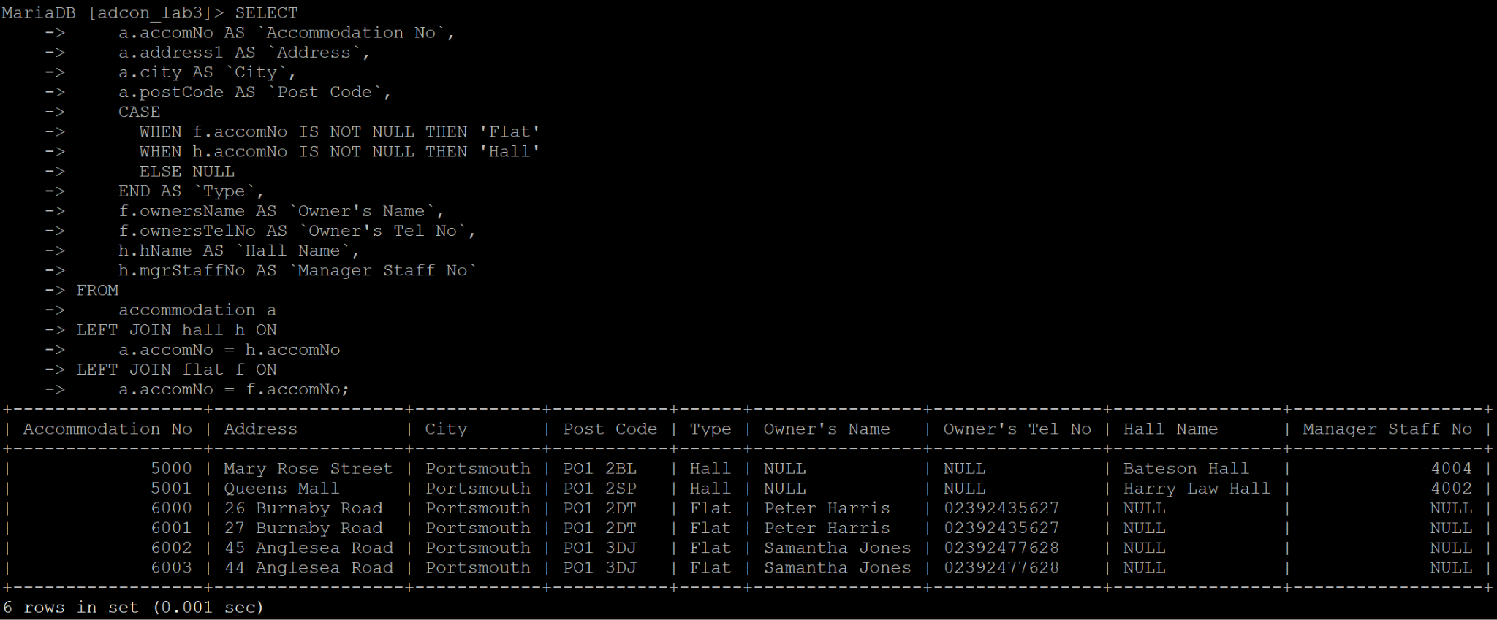

**Q2.** Copy and paste the question from the lab document (e.g. Extract (CREATE VIEW) of the console game titles ordered by platform name in ascending order and year of release in descending order).

**Answer:** Provide your solution along with code (if any) and a screenshot of the output. Provided code*MUST* be editable and NOT a screenshot, and the screenshot of the VMs output must have the code as well.

**Q3.** Copy and paste the question from the lab document (e.g. Extract (CREATE VIEW) of the console game titles ordered by platform name in ascending order and year of release in descending order).

**Answer:** Provide your solution along with code (if any) and a screenshot of the output. Provided code*MUST* be editable and NOT a screenshot, and the screenshot of the VMs output must have the code as well.

**Q4.** Copy and paste the question from the lab document (e.g. Extract (CREATE VIEW) of the console game titles ordered by platform name in ascending order and year of release in descending order).

**Answer:** Provide your solution along with code (if any) and a screenshot of the output. Provided code*MUST* be editable and NOT a screenshot, and the screenshot of the VMs output must have the code as well.

**Q5.** Copy and paste the question from the lab document (e.g. Extract (CREATE VIEW) of the console game titles ordered by platform name in ascending order and year of release in descending order).

**Answer:** Provide your solution along with code (if any) and a screenshot of the output. Provided code*MUST* be editable and NOT a screenshot, and the screenshot of the VMs output must have the code as well.

**Summary:** Provide a short summary of the lab what have you applied, what have you learned o what issues you have encountered and hod did you solved (*The summary is part of the marks, make sure that you are completing*)

*And you continue following the same pattern ….*

—---------------------------------------------------------------------------------------------------------------------------

LAB 2 (08/09/2025)

**Lab Questions**

**Q1.** Copy and paste the question from the lab document (e.g. Extract (CREATE VIEW) of the console game titles ordered by platform name in ascending order and year of release in descending order).

**Answer:** Provide your solution along with code (if any) and a screenshot of the output. Provided code*MUST* be editable and NOT a screenshot and the screenshot of the VMs output must have the code as well.

**Q2.** Copy and paste the question from the lab document (e.g. Extract (CREATE VIEW) of the console game titles ordered by platform name in ascending order and year of release in descending order).

**Answer:** Provide your solution along with code (if any) and a screenshot of the output. Provided code*MUST* be editable and NOT a screenshot and the screenshot of the VMs output must have the code as well.

**Q3.** Copy and paste the question from the lab document (e.g. Extract (CREATE VIEW) of the console game titles ordered by platform name in ascending order and year of release in descending order).

**Answer:** Provide your solution along with code (if any) and a screenshot of the output. Provided code*MUST* be editable and NOT a screenshot and the screenshot of the VMs output must have the code as well.

**Q4.** Copy and paste the question from the lab document (e.g. Extract (CREATE VIEW) of the console game titles ordered by platform name in ascending order and year of release in descending order).

**Answer:** Provide your solution along with code (if any) and a screenshot of the output. Provided code*MUST* be editable and NOT a screenshot and the screenshot of the VMs output must have the code as well.

**Q5.** Copy and paste the question from the lab document (e.g. Extract (CREATE VIEW) of the console game titles ordered by platform name in ascending order and year of release in descending order).

**Answer:** Provide your solution along with code (if any) and a screenshot of the output. Provided code*MUST* be editable and NOT a screenshot and the screenshot of the VMs output must have the code as well.

**Summary:** Provide a short summary of the lab what have you applied, what have you learned o what issues you have encountered and hod did you solved (*The summary is part of the marks, make sure that you are completing*)

*And you continue following the same pattern ….*

—---------------------------------------------------------------------------------------------------------------------------

LAB 3 (18/09/2025)

**Lab Questions**

**Q1.** Copy and paste the question from the lab document (e.g. Extract (CREATE VIEW) of the console game titles ordered by platform name in ascending order and year of release in descending order).

**Answer:** Provide your solution along with code (if any) and a screenshot of the output. Provided code*MUST* be editable and NOT a screenshot and the screenshot of the VMs output must have the code as well.

**Q2.** Copy and paste the question from the lab document (e.g. Extract (CREATE VIEW) of the console game titles ordered by platform name in ascending order and year of release in descending order).

**Answer:** Provide your solution along with code (if any) and a screenshot of the output. Provided code*MUST* be editable and NOT a screenshot and the screenshot of the VMs output must have the code as well.

**Q3.** Copy and paste the question from the lab document (e.g. Extract (CREATE VIEW) of the console game titles ordered by platform name in ascending order and year of release in descending order).

**Answer:** Provide your solution along with code (if any) and a screenshot of the output. Provided code*MUST* be editable and NOT a screenshot and the screenshot of the VMs output must have the code as well.

**Q4.** Copy and paste the question from the lab document (e.g. Extract (CREATE VIEW) of the console game titles ordered by platform name in ascending order and year of release in descending order).

**Answer:** Provide your solution along with code (if any) and a screenshot of the output. Provided code*MUST* be editable and NOT a screenshot and the screenshot of the VMs output must have the code as well.

**Q5.** Copy and paste the question from the lab document (e.g. Extract (CREATE VIEW) of the console game titles ordered by platform name in ascending order and year of release in descending order).

**Answer:** Provide your solution along with code (if any) and a screenshot of the output. Provided code*MUST* be editable and NOT a screenshot and the screenshot of the VMs output must have the code as well.

**Summary:** Provide a short summary of the lab what have you applied, what have you learned o what issues you have encountered and hod did you solved (*The summary is part of the marks, make sure that you are completing*)

*And you continue following the same pattern ….*

—---------------------------------------------------------------------------------------------------------------------------